**Exp 1 – OPTIONAL**

Aryaman Gautam

J001

/*

Create an LED chaser

*/

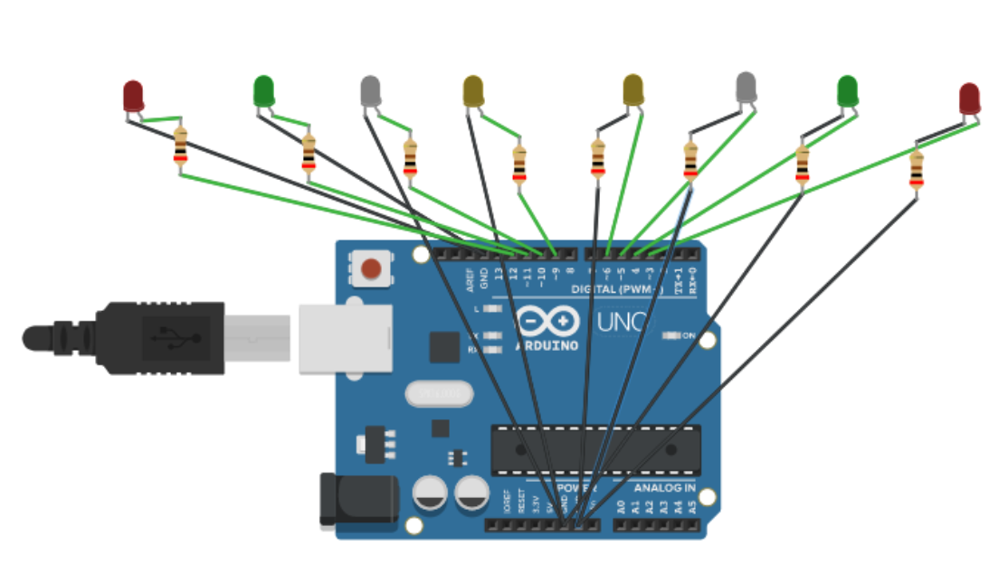

void setup()

{

for(int i = 3;i<13;i++)

{

pinMode(i, OUTPUT);

if(i == 6)

{

i += 2;

}

}

}

void loop()

{

for(int i = 3;i<13;i++)

{

digitalWrite(i, HIGH);

delay(500);

digitalWrite(i, LOW);

delay(500);

if(i == 6)

{

i += 2;

}

}

for(int i = 12;i>2;i--)

{

digitalWrite(i, HIGH);

delay(500);

digitalWrite(i, LOW);

delay(500);

if(i == 9)

{

i -= 2;

}

}

}